**FRONT PAGE**

One Month Industry Internship Report

On

**Development of Full Stack File Viewing System- Virtual Machines**

_______________________________________________________________

At

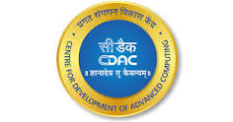

Centre for Development of Advanced Computing, Pune

Submitted by

Shrivatsa Indra Guru

Under the Guidance of

External Supervisor External Guide

Ms. Yogeshwari Patil Mr. Neelesh Kharkar

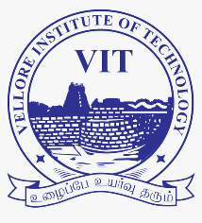

Department of Computer Science & Engineering

Vellore Institute of Technology, Vellore, Tamil Nadu

June, 2025

Academic Year 2025-26

**DECLARATION**



Declaration

I, Shrivatsa Indra Guru, student at Vellore Institute of Technology, Vellore- pursuing B. Tech in Computer Engineering, hereby declare that the internship report entitled " One Month Industry Internship Report" is a record of authentic work carried out by me Centre for Development of Advanced Computing, Pune, during the period 15th May to 18th June 2025.

I affirm that the internship report represents my own work, and any external sources used have been duly acknowledged and referenced. I further declare that the contents of this report have not been submitted, either partially or in full, for any other degree or qualification at this or any other institution.

Throughout the internship, I have adhered to the ethical standards set by the organization, maintaining confidentiality, and respecting the proprietary information of the company. The insights and findings presented in this report are based on my personal observations, experiences, and contributions during the internship period.

I acknowledge the guidance and support received from my mentors, Mr. Neelesh Kharkar and Ms. Yogeshwari Patil at C-DAC, who provided valuable insights and feedback to enhance the quality of my internship experience and this report.

Name: Shrivatsa Indra Guru Signature: _______________

**ACKNOWLEDGEMENT**



ACKNOWLEDGEMENT

I would like to express my sincere gratitude to all those who have contributed to the successful completion of my internship and the preparation of this report.

First and foremost, I extend my heartfelt thanks to my mentor, Mr. Neelesh Kharkar Sir, for providing me with the opportunity to be a part of his team. His guidance, mentorship, and constructive feedback were invaluable, shaping my understanding and enhancing my skills in Full Stack Development as well as Virtual Machines.

Special thanks to Ms. Yogeshwari Patil Ma’am for her guidance and support throughout the internship. The shared experiences and knowledge exchange significantly enriched my learning journey.

I am grateful to the entire team at C-DAC, Pune for their warm welcome, support, and cooperation during my internship. The collaborative work environment allowed me to gain practical insights and apply theoretical knowledge to real-world scenarios.

Finally, I want to thank my family and friends for their unwavering support, encouragement, and understanding during this internship period. Their motivation played a crucial role in my ability to navigate challenges and successfully complete this internship.

This report would not have been possible without the collective support and encouragement from all these individuals and entities. I am truly grateful for their contributions to my professional development.

Shrivatsa Indra Guru

**INDEX**

INDEX PAGE

|  |  |  |
| --- | --- | --- |
| Sr. No. | Contents | Page No |
| 1 | Introduction of Industry & Organization Structure | 05 |
| 2 | Introduction of Product/Service/Software | 07 |
| 3 | Introduction of work assigned | 09 |
| 4 | Detailed Study | 10 |
| 5 | Outcome (Case Study) | 13 |
| 6 | Schematic Diagram and Explanation | 20 |
| 8 | Participation of External and Internal Guide | 23 |
| 9 | Conclusion | 24 |

**INTRODUCTION OF INDUSTRY & ORGANIZATION STRUCTURE**

Introduction of Industry

C-DAC with its focus in Advanced Computing is uniquely positioned to establish dependable and secure Exascale Ecosystem offering services in various domains. C-DAC has crafted its strategic practical roadmap keeping in perspective the paradigm shift in the global technological ecosystem and ever-dynamic area of national ICT scenario. Accordingly, the roadmap has been devised with a four-pronged approach based on the Core as HPC & Cloud., viz. Futuristic Research, Applied R&D, Applications and Services covering 28 thrust areas. Towards realization of the roadmap, mission mode programmes were evolved to research, develop and deliver the futuristic technologies/solutions.

C-DAC, Pune occupies a special place in the evolution of the organization as a premier hub for cutting edge R&D. Bestowed with the distinction of being the first C-DAC centre to be established in the country, C-DAC, Pune has been at the forefront of the organization's R&D initiatives and spearheading several national programmes of strategic importance. C-DAC, Pune is credited for the first indigenously developed PARAM supercomputer

C-DAC has crafted its strategic practical roadmap keeping in perspective the paradigm shift in the global technological ecosystem and ever-dynamic area of national ICT scenario. The technological advancements in high-speed communication, intense computation, storage, and infrastructure coupled with mobility and accessibility has impacted the modalities of conducting business in a revolutionary manner.

**INTRODUCTION OF INDUSTRY & ORGANIZATION STRUCTURE**

Organization Structure

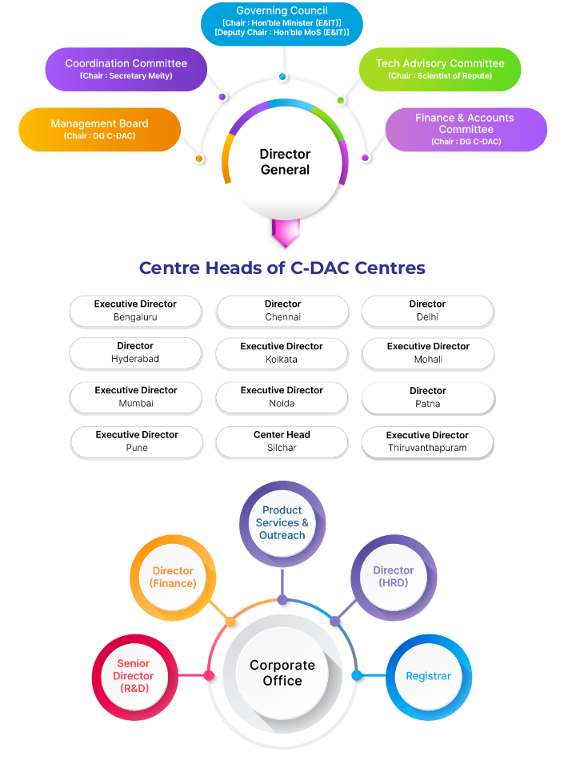

**INTRODUCTION OF PRODUCT/SERVICE/SOFTWARE**

Introduction of Product/Service/Software

**Project Name:**

Urban Environment Science to Society (UES2S)

**Purpose:**

To develop an integrated multi-scale modeling and data environment for Indian researchers and end-end decision support framework with high resolution meteorology, air quality, CFD and hydrology models using HPC technology to aid Indian policy makers, researchers, public and outreach community.

Urban Modeling: Development of multi-sectorial simulation lab and science-based decision support framework to address urban environment issues.

**Overview:**

The project has various models such as Hydrology, Meteorology, Air-quality, Computational Fluid Dynamics (CFD) models. The project aims to access the combined effect of these models.

An integrated platform is offered to users which includes the following:

* Science Gateway (HPC based fully automated model simulation)
* Data Hub (Data as a service & Data analytics)
* Integrated Decision & Support System (Air- Quality, Meteorology, Hydrology)

**INTRODUCTION OF PRODUCT/SERVICE/SOFTWARE**

Introduction of Product/Service/Software

**Stakeholders:**

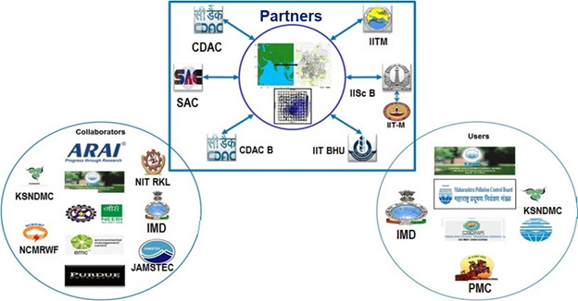

**INTRODUCTION OF WORK ASSIGNED**

Introduction of work assigned

During my internship at C-DAC, I had the opportunity to engage in a diverse range of tasks and projects that not only expanded my practical knowledge but also allowed me to contribute meaningfully to the goals of the organization.

Over the course of 1 month, I was assigned a variety of responsibilities that span research, problem solving, and project management. These tasks were meticulously designed to expose me to the intricacies of Virtual Machines and APIs development, thereby providing a holistic learning experience.

The primary objectives of the work assigned were to develop a File Viewing System using Java, Docker and Angular JS. I was required to develop code, test the code and deliver the desired application functionality. I was also assigned the task of developing a microservice, using Spring Boot, where I gained hands-on experience of dockerizing a project. This not only aligned with the mission of C-DAC, Pune but also presented a unique opportunity for me to apply theoretical knowledge acquired during my academic pursuits to real-world scenarios.

The scope of my responsibilities encompassed designing the UI/UX, implementing REST APIs, creating dynamic functions in the backend, and testing. Through these assignments, I gained insights into REST APIs, designing of an architecture, development and operational tasks. The following sections will delve into each aspect of the work assigned, detailing the methodologies employed, challenges encountered, and the outcomes achieved.

**DETAILED STUDY**

Detailed Study of the work assigned

**Project Name:**

* Urban Environment Science to Society (UES2S)

**Project Domain:**

* Full Stack Development
* REST APIs

**Technology Used:**

* Angular (JS)
* Spring Tool Suite (Spring Boot)
* Docker
* VirtualBox (for Virtual machines)

**DETAILED STUDY**

Project Domain

**Full Stack Development:**

**Overview:**

The file viewing web application is designed to offer users a seamless and efficient interface for browsing, previewing, and downloading various file types—including text, image, PDF, and location files—without the need to manually access server directories or navigate complex backend systems. By bridging a secure connection between an Angular frontend, a Spring Boot Web Server, and a Dockerized File Server, the application centralizes access to all files stored on the server infrastructure. This streamlined architecture eliminates the need for users to perform terminal-based operations or file system lookups, enabling them to effortlessly interact with and retrieve critical documents through a clean, user-friendly web interface.

**Development accomplishments:**

The project commenced with the design of the user interface and overall application layout based on the requirements provided by C-DAC, followed by the implementation of REST APIs developed using Spring Boot. These APIs were integrated into essential modules such as the Login module, File Listing module, and File Viewing module. The system dynamically fetched and displayed file metadata from a dedicated File Server VM, presenting the information in structured tables and enabling users to view selected files in new browser windows. Secure and efficient communication between the Web Server VM and the File Server VM was established using Docker-based networking, allowing hostname-based access instead of IP addresses. Additionally, the user interface was refined to meet C-DAC's specifications, including the development of an animated splash screen and other visual enhancements to ensure a seamless and user-friendly experience.

**DETAILED STUDY**

Technology Used

1. **VirtualBox:**

VirtualBox is a powerful, open-source x86 and AMD64/Intel64 virtualization product developed by Oracle. It allows users to run multiple operating systems simultaneously on a single physical machine by creating and managing virtual machines (VMs). Available for Windows, macOS, Linux, and Solaris hosts, VirtualBox is widely used for software development, testing, and learning purposes. It provides features like snapshots, shared folders, and bridged networking, making it ideal for simulating distributed systems or isolating development environments.

1. **Springboot:**

Spring Boot is an open-source, Java-based framework developed by Pivotal (now a part of VMware) that simplifies the development of stand-alone, production-grade Spring applications. It eliminates the need for complex configuration by offering auto-configuration and embedded servers like Tomcat, Jetty, or Undertow. Spring Boot is particularly suited for building RESTful APIs and microservices, enabling developers to focus on writing business logic without managing infrastructure concerns like XML configurations or WAR deployments.

1. **Docker:**

Docker is an open platform for developing, shipping, and running applications. Docker provides the ability to package and run an application in a loosely isolated environment called a container. The isolation and security lets you run many containers simultaneously on a given host. Containers are lightweight and contain everything needed to run the application, so you don't need to rely on what's installed on the host. You can share containers while you work, and be sure that everyone you share with gets the same container that works in the same way.

1. Angular:

Angular is a platform and framework for building single-page client applications using HTML, CSS, and TypeScript. Developed and maintained by Google, Angular provides a powerful component-based architecture, data binding, routing, and dependency injection. It is especially effective for building dynamic web applications and enterprise-level frontends that consume REST APIs. Angular's CLI tool allows rapid scaffolding of applications, testing, and deployment, making it a go-to choice for modern frontend development.

**OUTCOMES**

Outcomes of the work assigned

**File Server:**

Files used for testing:

**OUTCOMES**

Outcomes of the work assigned

Docker containerization:

**OUTCOMES**

Outcomes of the work assigned

Website UI:

**OUTCOMES**

Outcomes of the work assigned

PDF Viewer:

**OUTCOMES**

Outcomes of the work assigned

Text Viewer:

**OUTCOMES**

Outcomes of the work assigned

JPEG Viewer:

**OUTCOMES**

Outcomes of the work assigned

PNG Viewer:

**Schematic Diagram & Explanation**

Schematic Diagram and Explanation

Use Case Diagram:

Sequence Diagram:

**Schematic Diagram & Explanation**

Schematic Diagram and Explanation

Workflow Diagram:

**PARTICIPATION OF INTERNAL & EXTERNAL**

Participation of External and Internal Guide

Throughout the internship, I had the privilege of being supported by both an external guide within the organization and an internal guide from my college. My external guides, Mr. Neelesh Kharkar, along with Ms. Yogeshwari Patil, served as an invaluable mentor within the company, offering practical insights, guidance, and professional advice. Their expertise and experience within the organization allowed me to navigate the workplace dynamics effectively, understand the company's culture, and gain hands-on experience in various projects. Their mentorship played a pivotal role in aligning my learning objectives with the company's goals and practices.

The collaboration and coordination between my external guides were instrumental in ensuring a holistic learning journey. Their collective mentorship facilitated a comprehensive understanding of how theoretical concepts translate into practical implementations within the organizational context. Regular communication and feedback exchanges between these mentors were pivotal in maximizing the value of this dual guidance setup, allowing me to integrate academic theories with practical experiences seamlessly.

**CONCLUSION**

Conclusion

In concluding my internship at C-DAC, Pune, I reflect upon a transformative journey that has not only deepened my understanding of the industry but has also equipped me with invaluable skills and experiences that will undoubtedly shape my future endeavors. Throughout the internship, I had the privilege of working hands-on on diverse projects and tasks, each contributing to my professional growth and expanding my horizons.

The guidance and mentorship provided by my mentors, Mr. Neelesh Kharkar Sir and Ms. Yogeshwari Patil Ma’am, as well as the entire team at C-DAC have been instrumental in my development. Their insights, constructive feedback, and unwavering support have not only enhanced the quality of my work but have also instilled in me a sense of confidence and adaptability in navigating complex tasks.

The challenges encountered during the internship have been catalysts for personal and professional growth. Overcoming technical hurdles and collaborating with diverse teams provided opportunities for learning and innovation. The resilience developed in facing these challenges will undoubtedly serve as a foundation for future success.

As I conclude this internship report, I extend my sincere gratitude to everyone who has been part of this enriching experience. I am optimistic that the insights gained during this internship will not only contribute to my academic pursuits but will also serve as a steppingstone for a fulfilling and impactful career as a developer.